Section 1: The Billing Account
Q1: The Account Under Review 50 / 50 pts▲
The review flagged one billing account behaving oddly. Name it. That's who you're following.
Your answer: j.morris
Q2: Session Character and Source
This account isn't being used by someone sitting at the billing desk. Its successful sessions are a different kind of logon entirely, and they're not originating from inside the clinic either. Give the logon type, and one of the external sources driving it.
DeviceLogonEvents
| where Timestamp between (datetime(2026-03-08T00:00:00Z) .. datetime(2026-03-18T00:00:00Z))
| where DeviceName startswith "nh-"
| where AccountName =~ "j.morris"
| where ActionType == "LogonSuccess"
| summarize Count = count(), FirstSeen = min(Timestamp), LastSeen = max(Timestamp) by LogonType, RemoteIP, DeviceName
| order by Count desc
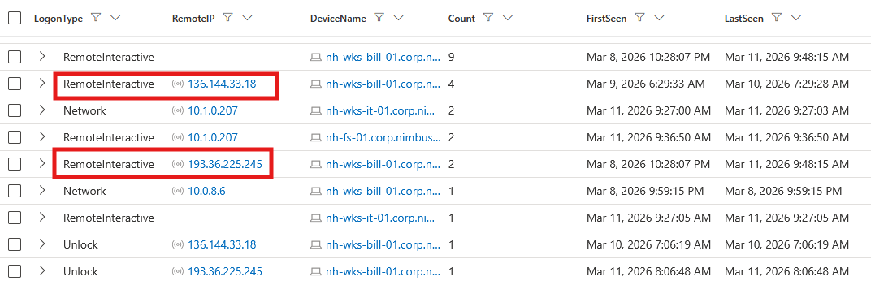
Your answer: RemoteInteractive, 193.36.225.245
Section 2: Hands on the Keyboard
Q1: Signal or Noise
Sort the account's command-shell activity by time. Not everything in the timeline is the operator, some of it is a computer doing its own housekeeping. Separate the two before building a theory on either.
DeviceProcessEvents
| where Timestamp between (datetime(2026-03-08T00:00:00Z) .. datetime(2026-03-18T00:00:00Z))
| where DeviceName startswith "nh-"
| where AccountName =~ "j.morris"
| where FileName in~ ("cmd.exe", "powershell.exe", "pwsh.exe", "powershell_ise.exe")
| project Timestamp, DeviceName, FileName, ProcessCommandLine, InitiatingProcessFileName, InitiatingProcessCommandLine
| order by Timestamp asc
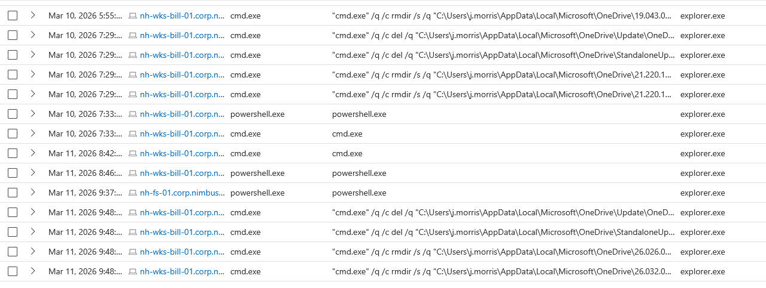

Your answer: noise onedrive doing maintenance
Q2: Getting Their Bearings
Past the noise, the account's operator runs a short, deliberate burst of native commands to get their bearings. Give that sequence, in order, including the server named on the final command.
DeviceProcessEvents
| where Timestamp between (datetime(2026-03-11T00:00:00Z) .. datetime(2026-03-11T23:59:59Z))
| where DeviceName startswith "nh-"
| where AccountName =~ "j.morris"
| project Timestamp, DeviceName, FileName, ProcessCommandLine, InitiatingProcessFileName, InitiatingProcessCommandLine
| order by Timestamp asc
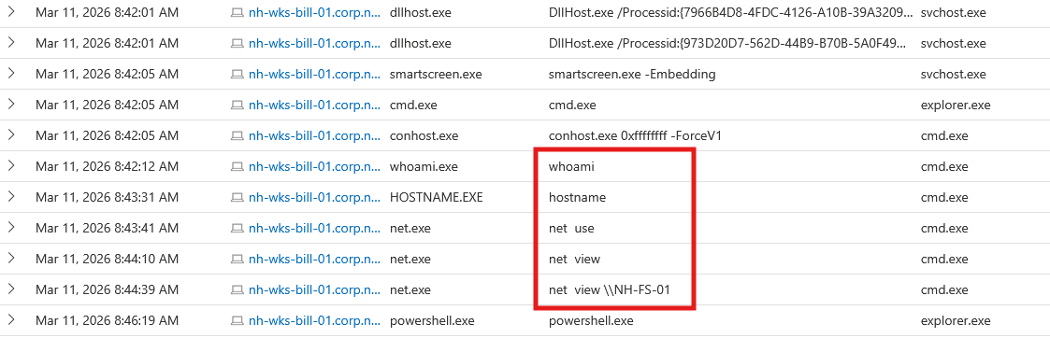
Your answer: whoami, hostname, net use, net view, net view \\NH-FS-01

